Vehicle Type | Typical Body Dimensions  L x W x H | Typical Payload | Loading Restrictions
Small van | 1.8m x 1.2 x 1.3 | 400kgs  1 pallet | Rear door  loading | 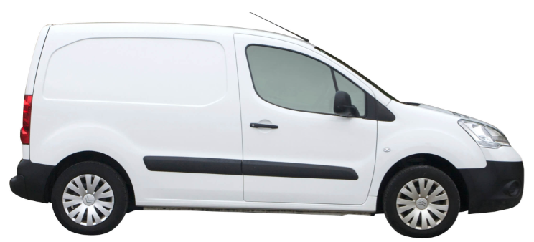
SWB Van | 2.5m x 1.5 x 1.5 | 800kgs  2 Pallets | Rear & side door loading | 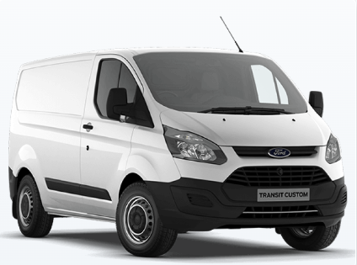
LWB Sprinter | 4m x 1.7 x 1.8 | 1000kgs 3 pallets | Rear & side door loading | 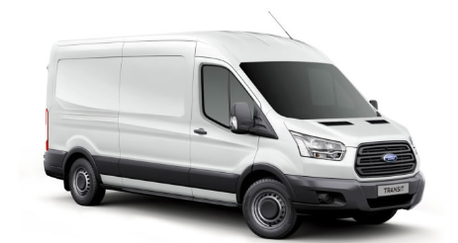
Luton Box Tail Lift Van | 4m x 1.8 x1.8 | 1000kgs 4 pallets | Rear load | 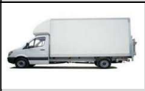
Luton Curtain-sided van | 4m x 2.0 x 1.8 | 1200kgs 4 pallets | Side or rear load | 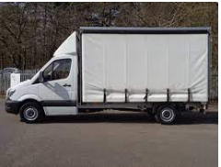
7.5 T Curtain Side | 6m x 2.4 x 2.2 | 2500kgs  10 pallets | Side or rear load | 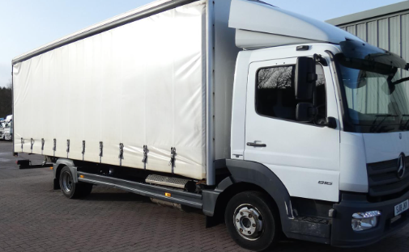
18t curtain Side | 7.5m x 2.4 x 2.4 | 9500kgs 14 pallets | Rear or side load | 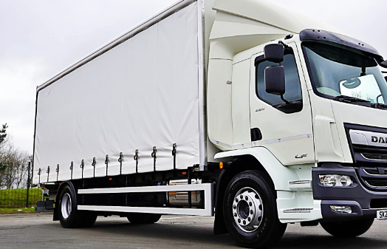
26 T Curtain side | 8m x 2.4 x 2.4 | 14500kgs  16 pallets | Rear or side load | 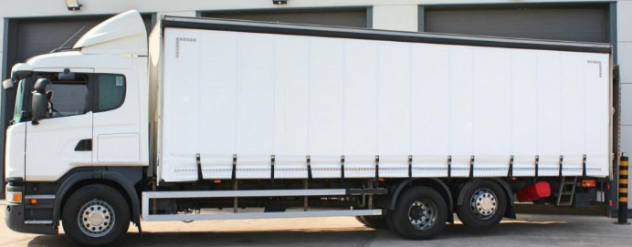
38T Tractor unit (4x2) | Pull up to |  |  | 